EXPT NO:3 | Designing Multivariate Patterns
DATE: 12.01.2026 | Designing Multivariate Patterns

PRE-LAB QUESTIONS (PROVIDE BRIEF ANSWERS TO THE FOLLOWING QUESTIONS)
- Why is multivariate analysis essential in real-world AI problems?
Multivariate analysis is essential because real-world AI problems involve multiple interacting variables. It helps AI models understand complex relationships, dependencies, and patterns among features, leading to more accurate predictions, better decision-making, and improved performance in domains like healthcare, finance, and robotics.
- What challenges arise when visualizing high-dimensional data?
Visualizing high-dimensional data is challenging because humans can only perceive up to three dimensions easily. As dimensions increase, plots become cluttered and confusing, causing information loss. Dimensionality reduction techniques are often required to preserve important patterns while improving interpretability.
- How does correlation analysis support feature selection?
Correlation analysis helps feature selection by identifying relationships between variables. Highly correlated features may be redundant and can be removed to reduce complexity. It also highlights features strongly related to the target variable, improving model efficiency, reducing overfitting, and enhancing overall prediction accuracy.
- What are ethical concerns in healthcare data visualization?
Ethical concerns include patient privacy, data confidentiality, and informed consent. Improper visualization can expose sensitive information or misrepresent data, leading to biased decisions. Ensuring anonymization, fairness, and accurate representation is crucial to prevent harm and maintain trust in healthcare AI systems.
- Give examples of multivariate data in AI systems.
Examples of multivariate data include electronic health records with vitals, lab results, and diagnoses; sensor data from autonomous vehicles; financial datasets with income, spending, and credit scores; and user behavior data involving clicks, time spent, and preferences.
IN-LAB EXERCISE:
OBJECTIVE:
To discover relationships among multiple variables using multivariate visualization.
SCENARIO:
A hospital analytics team studies patient health records to identify relationships between age, BMI, glucose levels, and blood pressure for early disease prediction.
IN-LAB TASKS (Using R Language)
- Generate scatter plot matrix
- Apply color encoding for age groups
- Identify correlated health indicators

CODE:
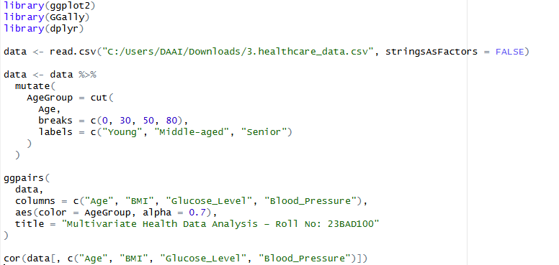

OUTPUT:
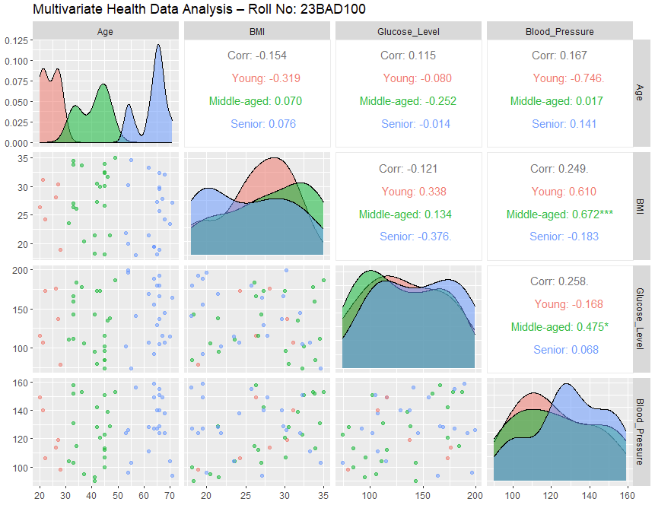

POST-LAB QUESTIONS (PROVIDE BRIEF ANSWERS TO THE FOLLOWING QUESTIONS)
- Which health parameters show strong correlation?
From the correlation matrix, no health parameters show strong correlation. Age, BMI, glucose level, and blood pressure have weak to moderate correlations. This indicates that these health indicators vary independently in the dataset and no single parameter strongly predicts another linearly.
- Why correlation does not imply causation in medical data?
Correlation does not imply causation because medical variables can be influenced by confounding factors such as genetics, lifestyle, diet, or environment. Even if two health parameters move together, one may not directly cause the other without clinical or biological evidence.
- How can these patterns assist predictive healthcare AI?
These patterns help predictive healthcare AI identify relevant features and interactions among variables. Understanding correlations improves feature selection, reduces redundancy, and enhances model accuracy. Such insights support early disease risk prediction and personalized treatment recommendations in intelligent healthcare systems.
- What visualization limitations exist for high-dimensional data?
High-dimensional data visualization is limited because humans can interpret only two or three dimensions at a time. As dimensions increase, plots become cluttered and overlapping, making patterns difficult to detect and reducing clarity and interpretability of relationships among variables.
- How can dimensionality reduction improve visualization?
Dimensionality reduction techniques like PCA compress high-dimensional data into fewer dimensions while preserving important patterns. This reduces noise, improves clarity, and makes visual analysis easier, allowing hidden structures and relationships to be identified more effectively in healthcare datasets.

ASSESSMENT
Description | Max Marks | Marks Awarded
Pre Lab Exercise | 5
In Lab Exercise | 10
Post Lab Exercise | 5
Viva | 10
Total | 30
Faculty Signature

Repository Link:
https://github.com/sanjeevdev91/U18AII5202_23BAD100

